**Training Management System**

**High Level Design Document**

1. **Introduction**

Training Management System is a platform that provides functionality of automated Training System which includes “to and fro” solution for conducting trainings in an organization. The system will help the L&D (Learning and Development) department of the company by minimizing their tasks of posting the training calendar in mails, creating list of attendees and all the manual tasks that is required to organize training. Users (Employees) will be able to select training available and to get enrolled in it according to the seats availability.

1. **Purpose :**

To automate the process of organizing training in the company. Current situation is that, all the work w.r.t. organize training in the company is done manually. From posting training calendar to seeking nominations, creating a list of employees and finally filling the feedback form, all this work is done manually via emails, which takes efforts from both the sides (L&D and employee).

1. **Current State:**

Following is the current flow-

1. ADMs or Managers fill the TRF (Training Request Form) on portal or send a mail to Talent Management for the identified training to be organized for the team as per the business requirement or client need.
2. Post receiving a request and subsequent approval for the same, TM searches for trainers both internally as well as external trainers.
3. TM searches for internal trainers in the internal trainer pools where record of previous trainers are captured and stored.
4. In case there are no internal trainers, TM checks availability for external trainers with the vendors. They provide the vendors with details of the training that needs to be conducted, so that they can find suitable trainers with relevant experience.
5. Vendors share the details of the trainers along with quotation as well as the content that will be used to the TM team.
6. TM team further shares details received from vendors to the respective managers, ADM’s or delivery heads for approval.
7. Trainers are evaluated and the cost of training needs to be approved by delivery heads.
8. IT team and facilities team are contacted in case there are any such requirements.
9. Post the completion of training, TM team shares the feedback and evaluation forms to both trainer as well as employees to capture their responses.



1. **Future State**
   1. High Level Design:

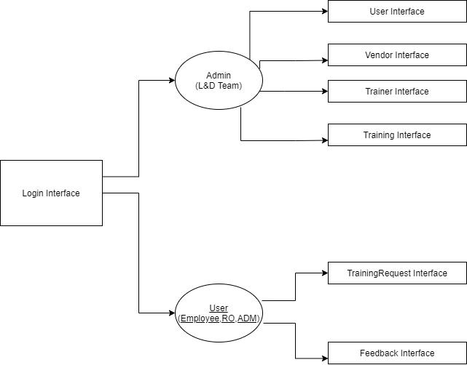

* 1. Class Diagram:

